**JENKINS SETUP**

**==============================================================================**

**Source Code Management:=== give git hub URL**

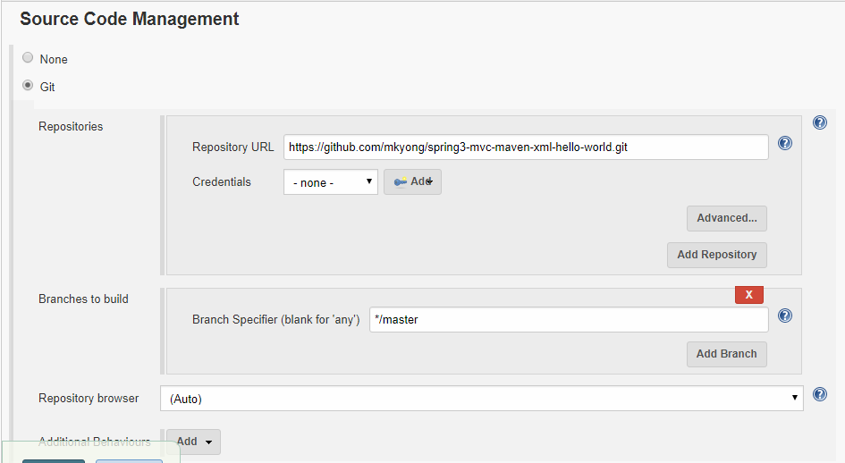

**==============================================================================**

**Build:=== clean install**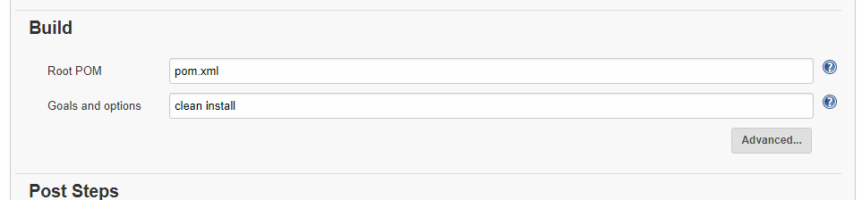

**===========================================================================**

**Post Bill Action:=== Deploy war/ear to container**

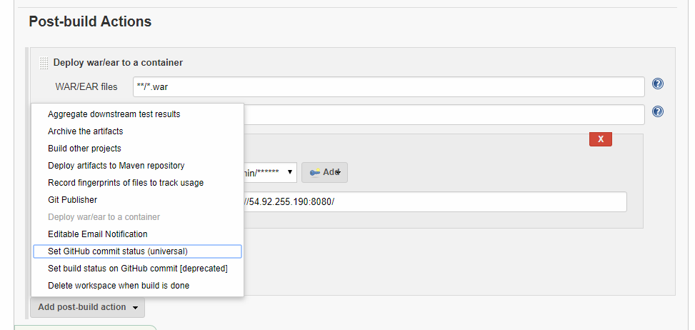

**===========================================================================**

**Tomcat credentials:=== Give credentials**

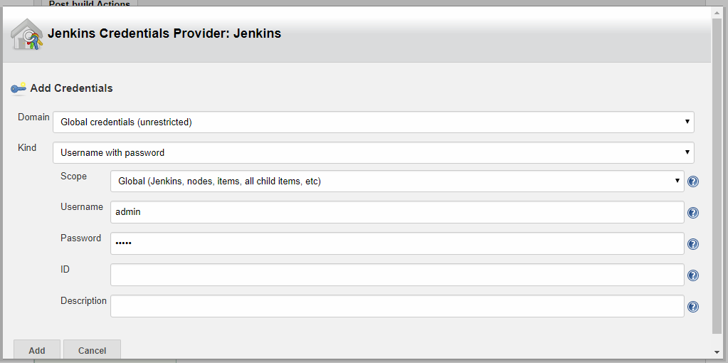

**===========================================================================**

**Tomcat credentials:=== Give credentials**

**GLOBAL TOOL CONFIGURATION**

**==========================================================================**

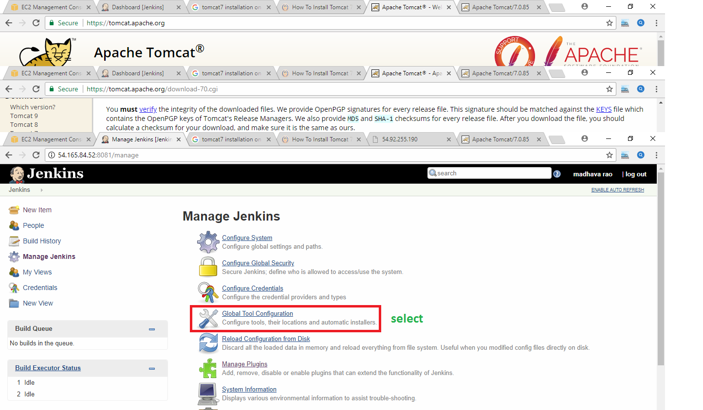

**==========================================================================**

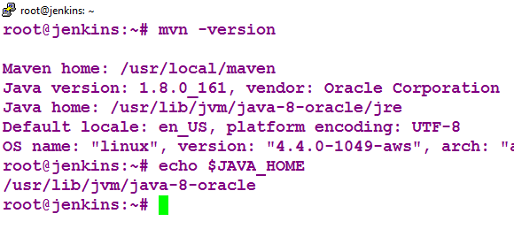

**==========================================================================**

**JAVA HOME:===**

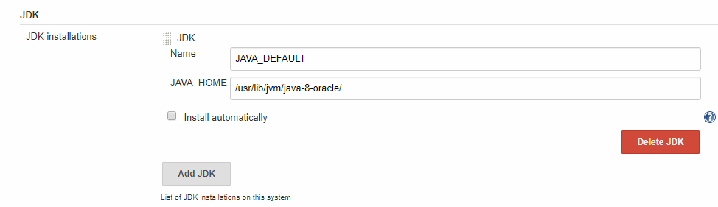

**==========================================================================**

**MAVEN HOME:===**

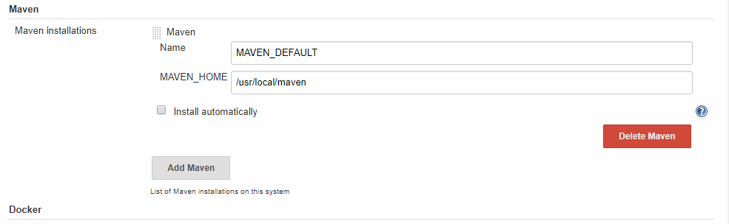

**PLUGINS**

**==========================================================================**

**MAVEN PLUGIN:=== for maven project**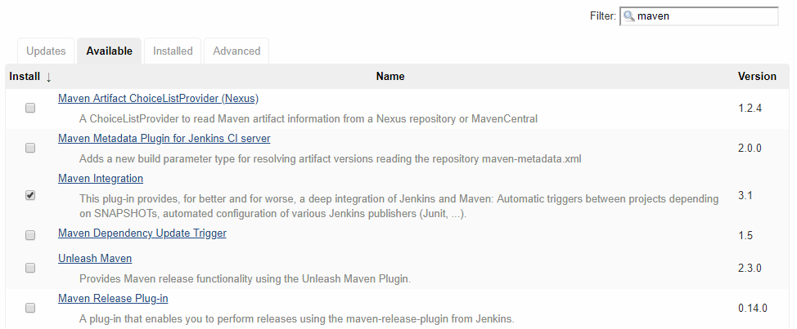

**==========================================================================**

**DEPLOY TO CONTAINER PLUGIN:=== for war file deployment**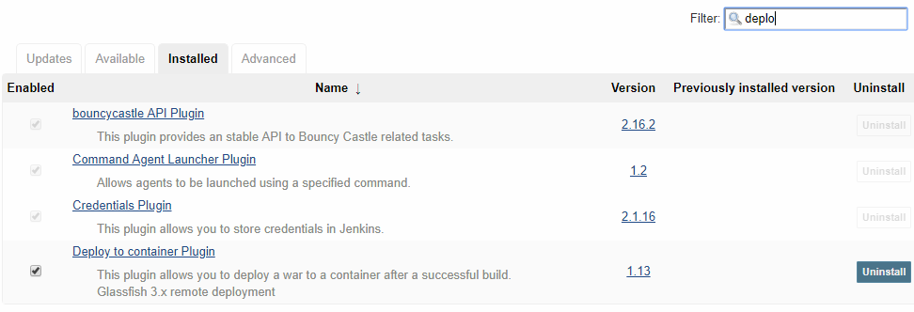

**==========================================================================**

**S3 Bucket plugin:=== for war file deployment in S3 Bucket**

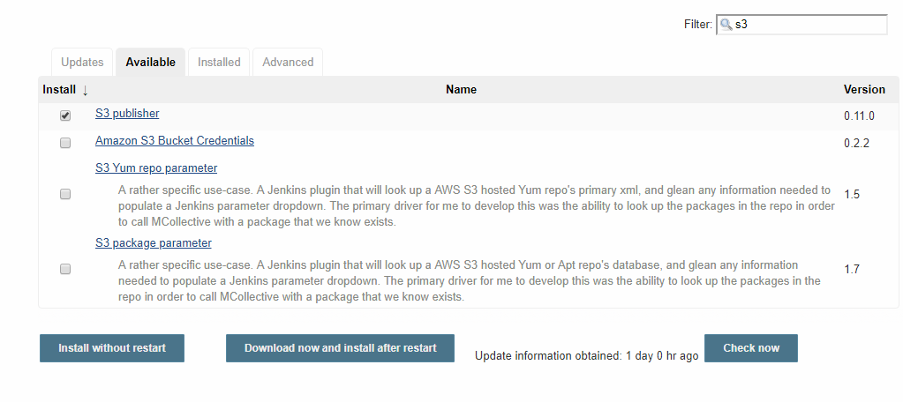

**==========================================================================**

**Jfrog artifactory plugin:=== for war file deployment in artifactory**

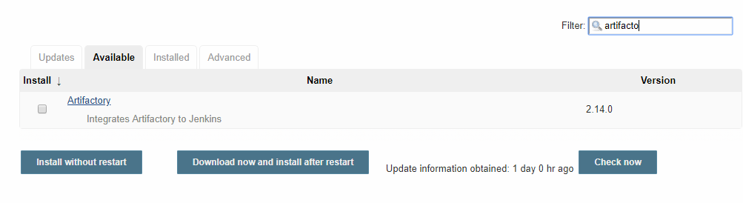

**Configuration System**

**==========================================================================**

**S3 setup :=== for maven project**

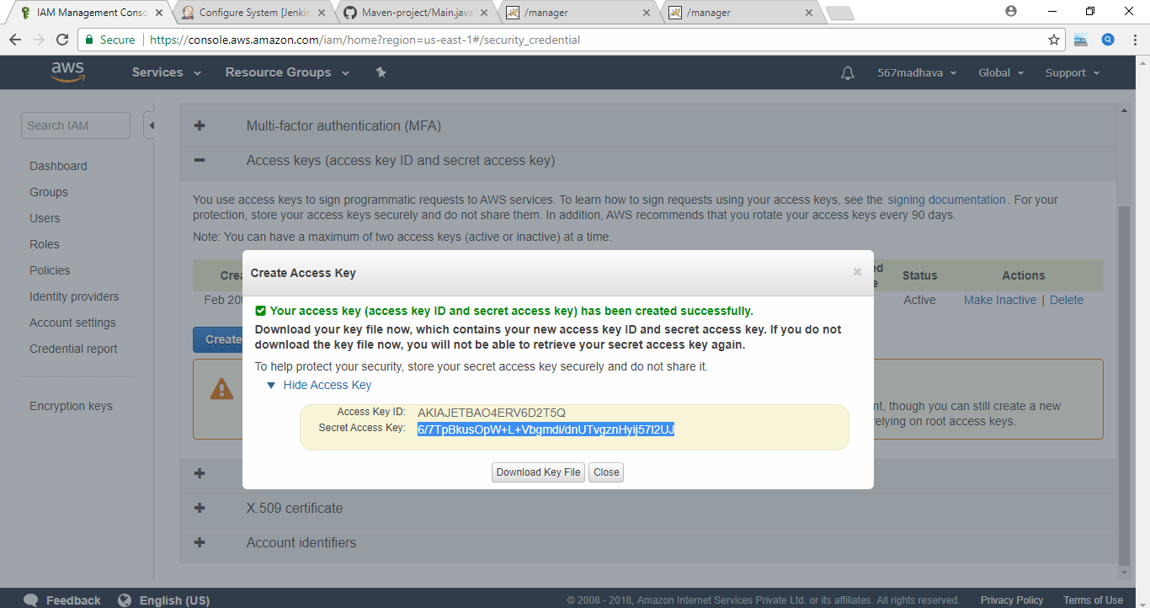

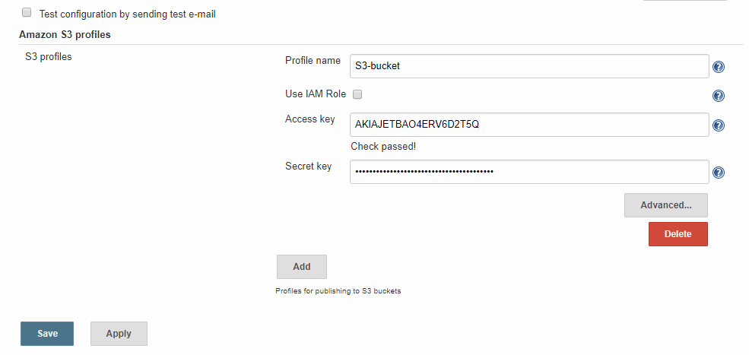

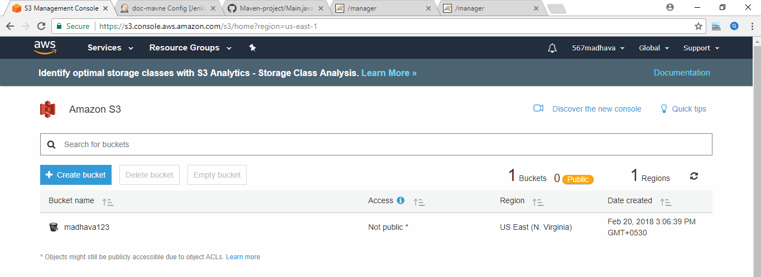

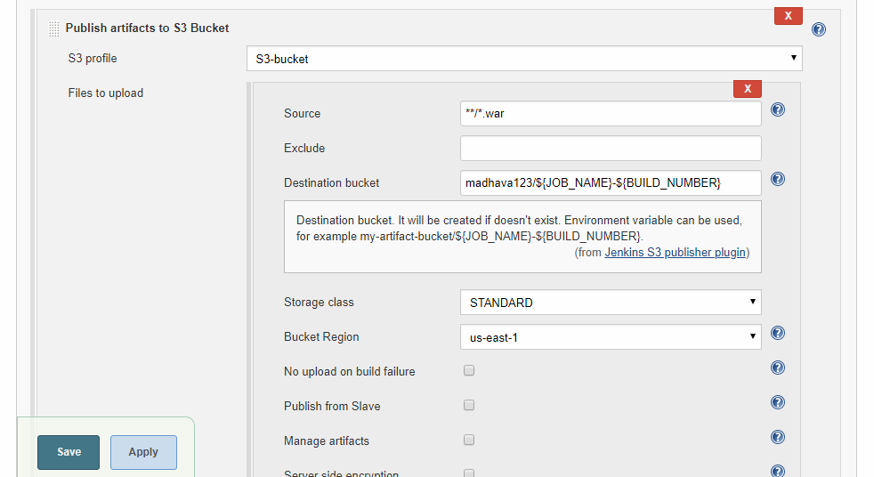

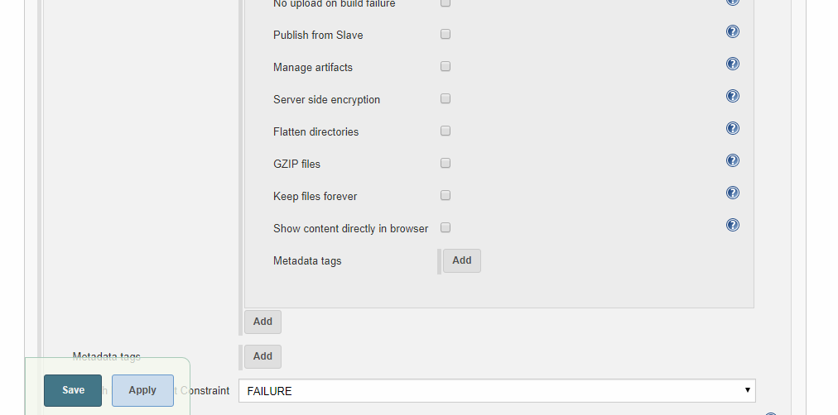

**==========================================================================**

**==========================================================================**

**Jfrog Artifactory :=== for maven project**

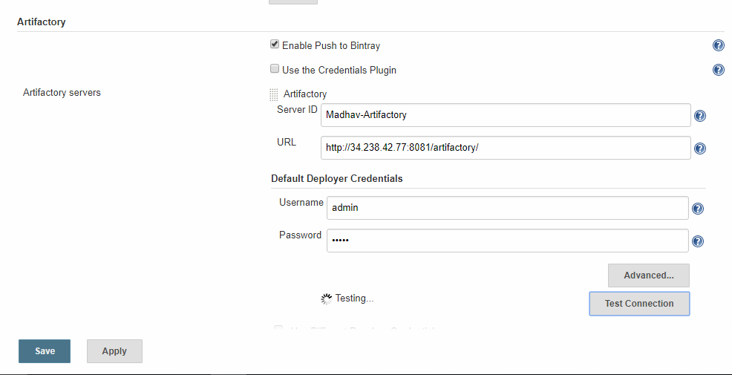

JFROG

